Spyder interface for app(ml).py

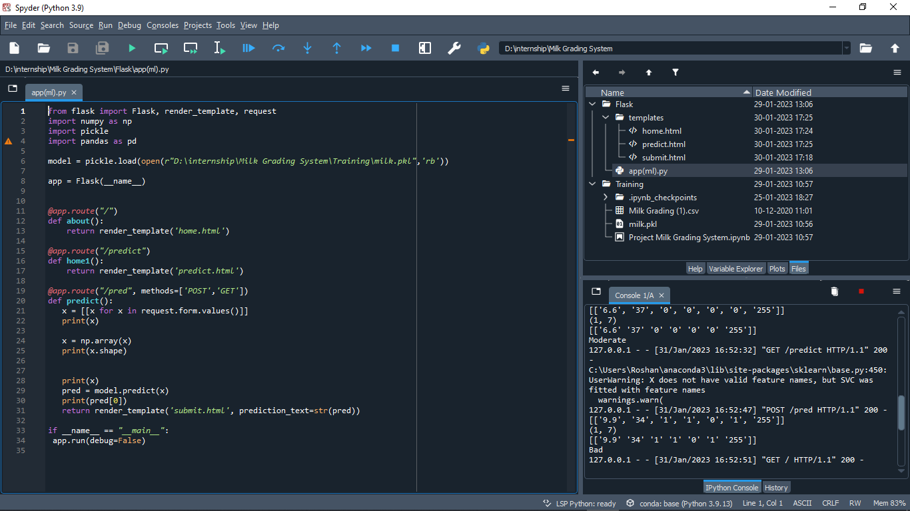

Spyder interface for Home.html

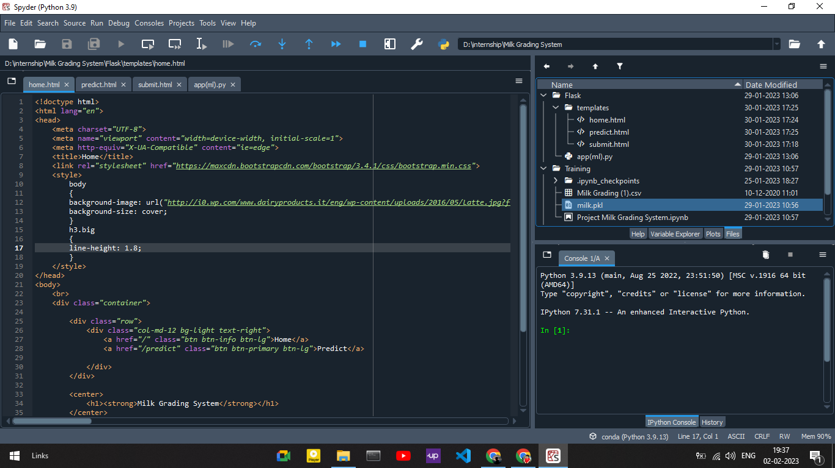

Spyder interface for Home.html

Spyder interface for predict.html

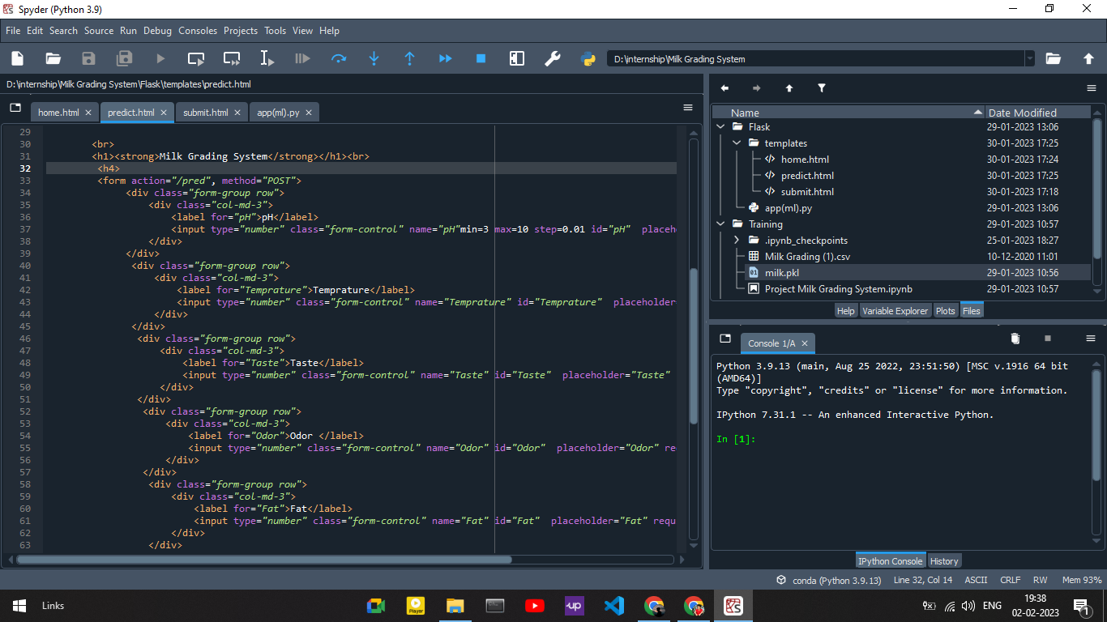

Spyder interface for submit.html

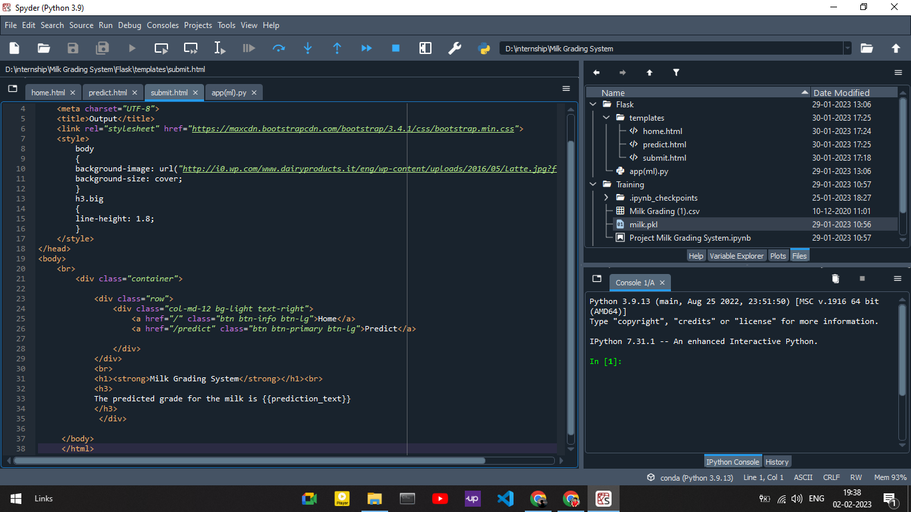

Home page for Milk Grading System

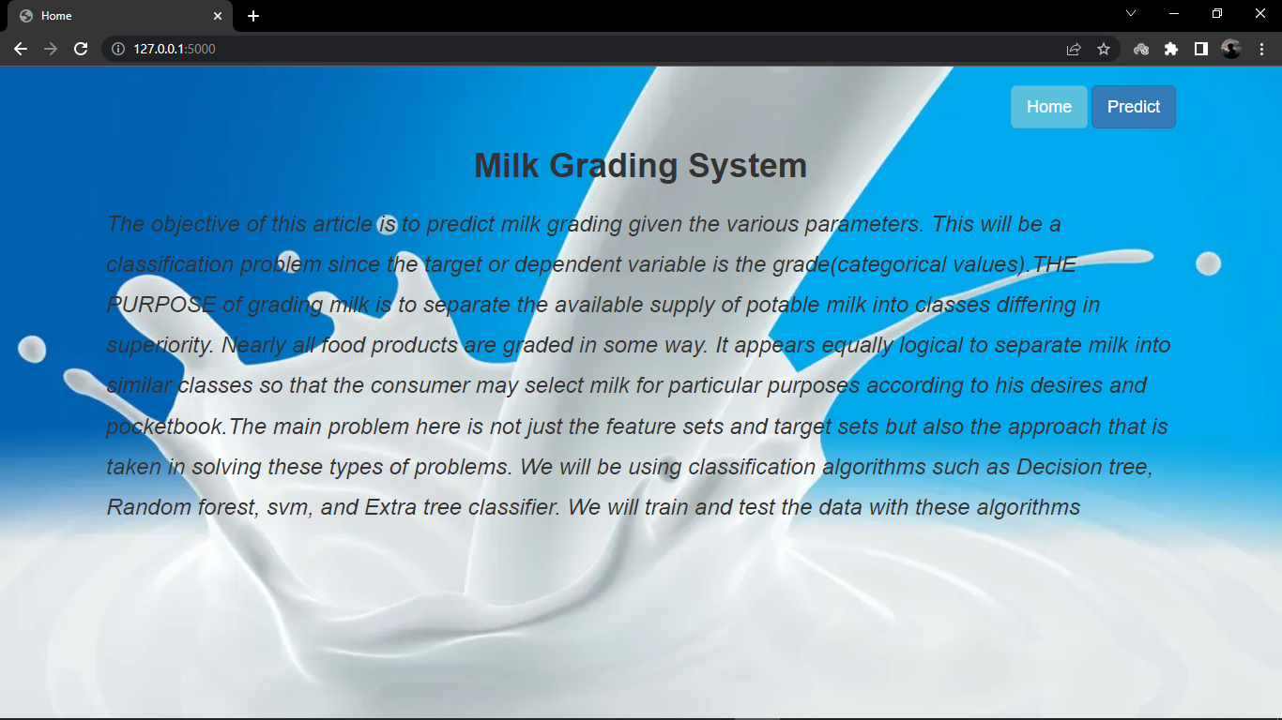

Predict 1 page for Milk Grading System

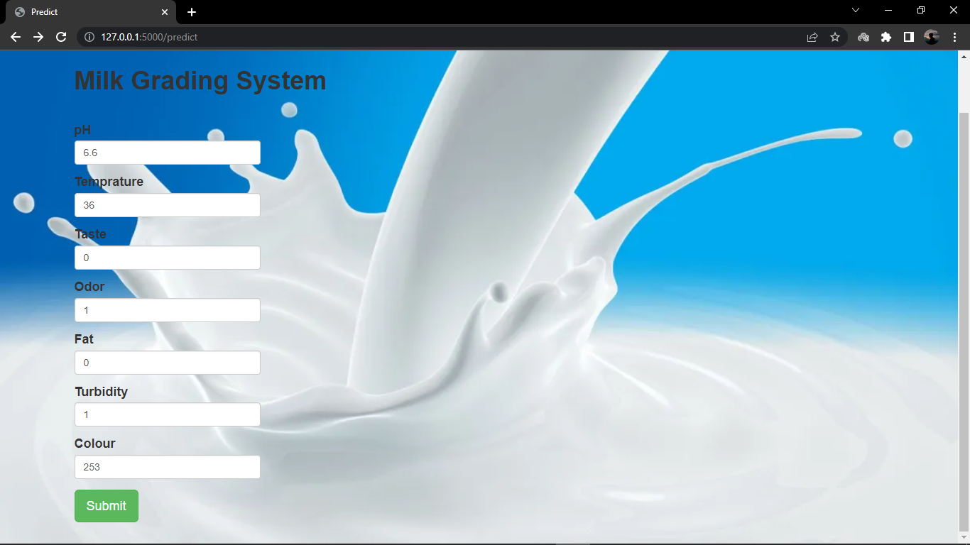

Output 1 page for Milk Grading System

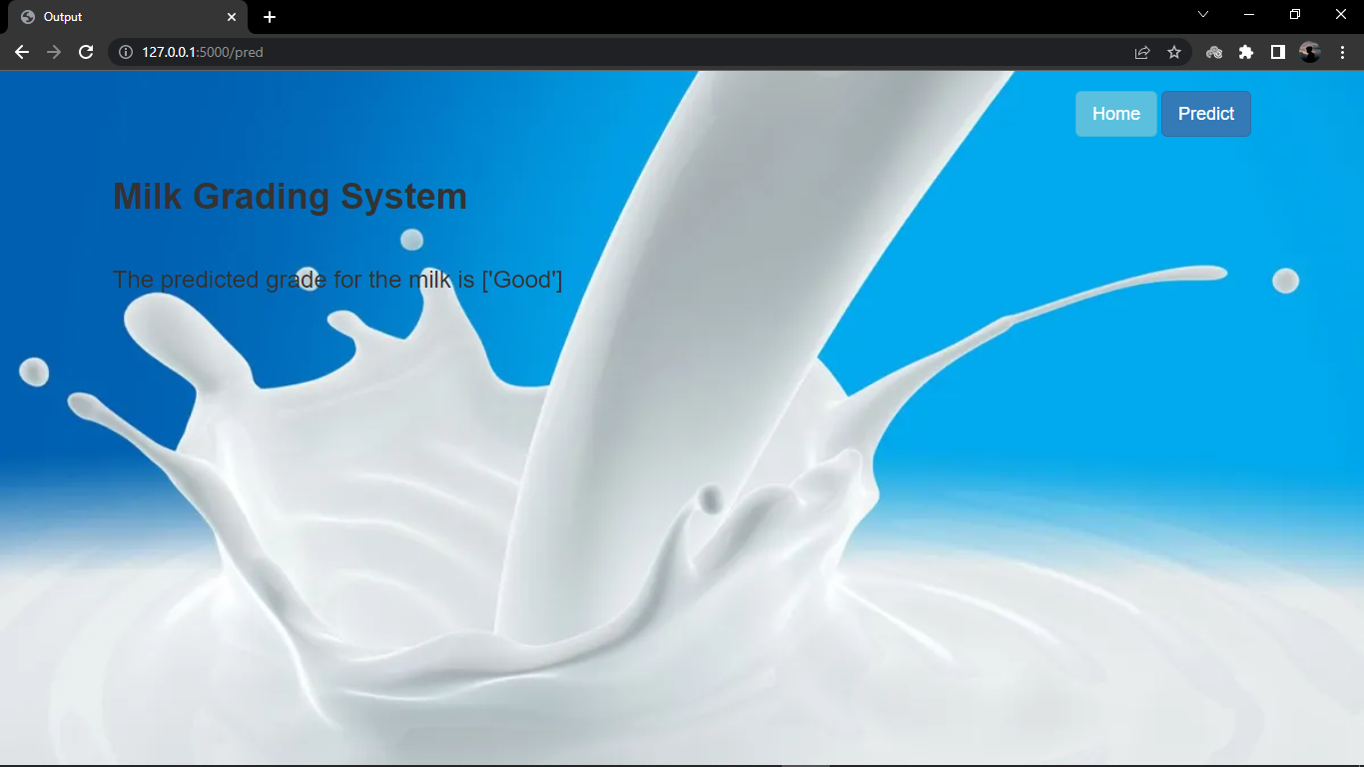

Predict 2 page for Milk Grading System



Output 2 page for Milk Grading System

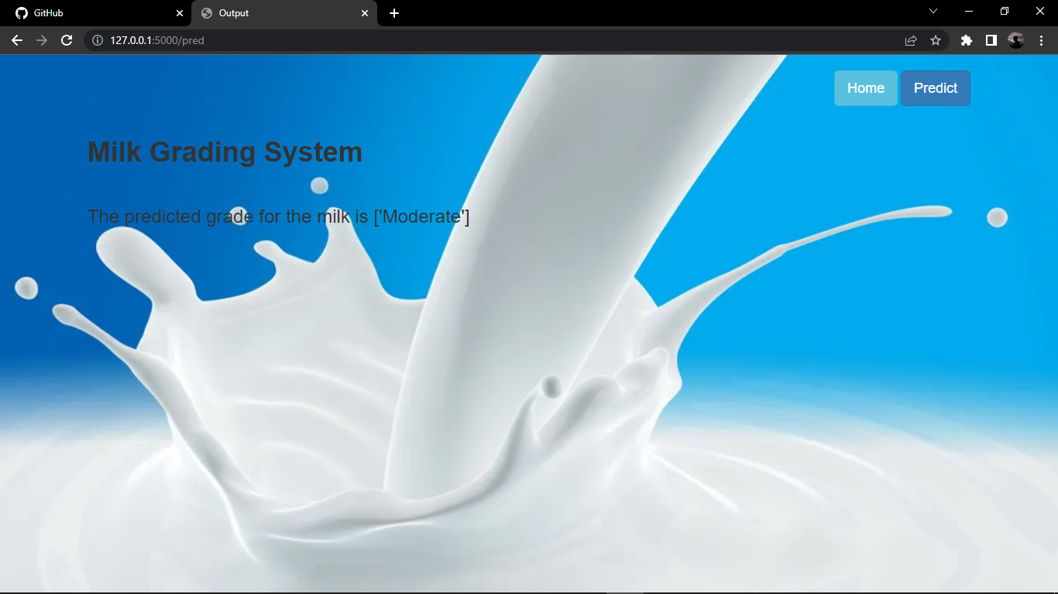

Predict 3 page for Milk Grading System

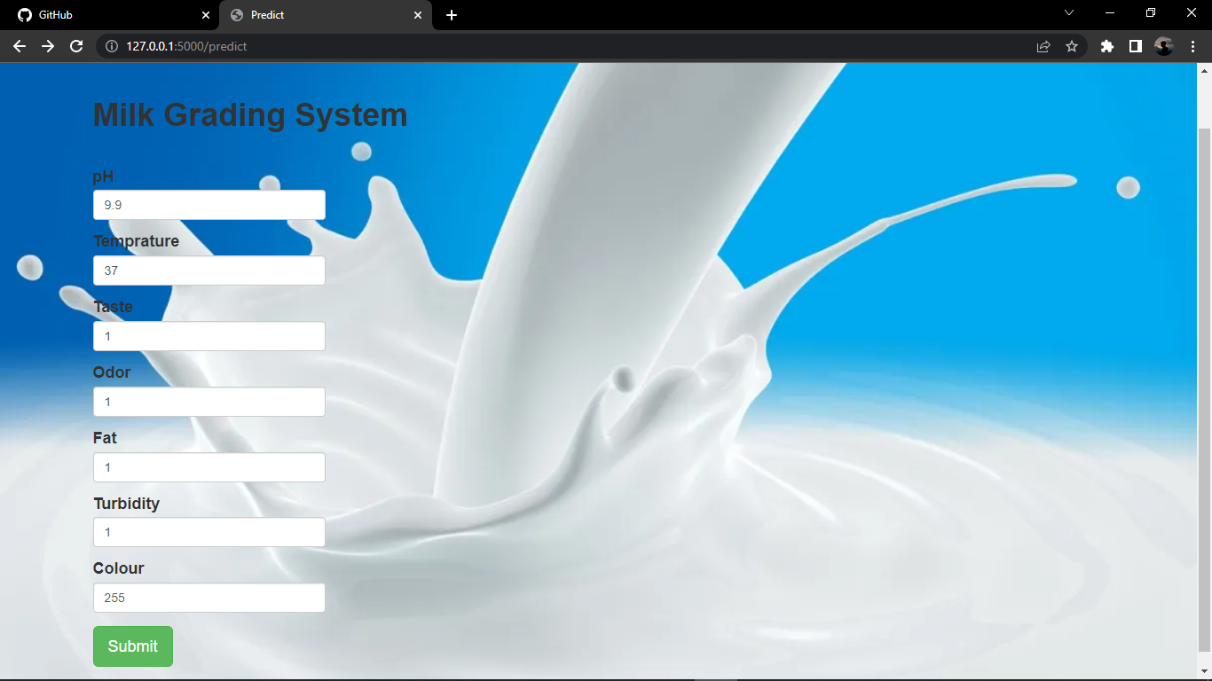

Output 3 page for Milk Grading System

